Waterman Family Images
Second Lieutenant George L. Waterman
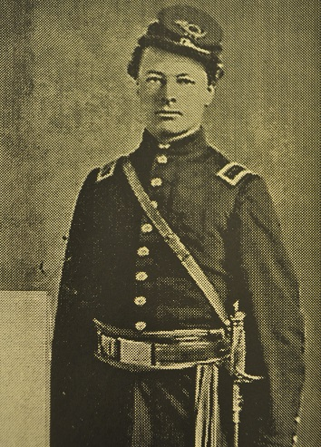
Question: What components of Lieutenant Waterman’s uniform indicate that he is an officer in the Union Army?
Lieutenant Waterman’s Father, Lawson Waterman- Farmer, Boat Builder, Quarry Owner
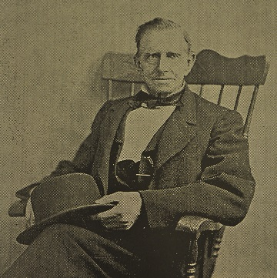
Questions: What does Mr. Waterman’s dress and pose indicate about his role in Peninsula business and politics? In making his voting decision in the 1864 presidential election, how might he balance his feelings about the loss of his son in military service with his responsibilities to keep his businesses profitable?
Lieutenant Waterman’s Mother, Angelina Waterman
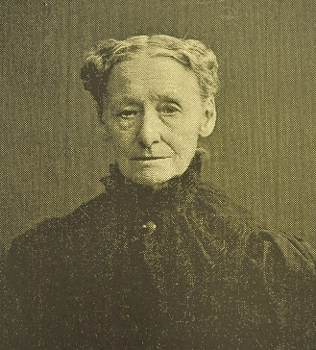
Question: Having lost her only child to military service, what role might Mrs. Waterman play after the war in relation to her husband’s businesses and the town of Peninsula in general?
Sketch of Waterman’s Boat Yard
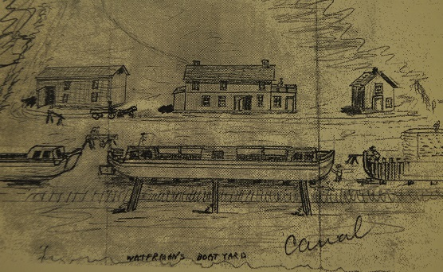
Questions: Had he lived, what role might Lieutenant Waterman play in this business after the war? How about Sergeant Boodey who wrote about working in the boat yards after the war?
Waterman Family Home and Farm post-Civil War
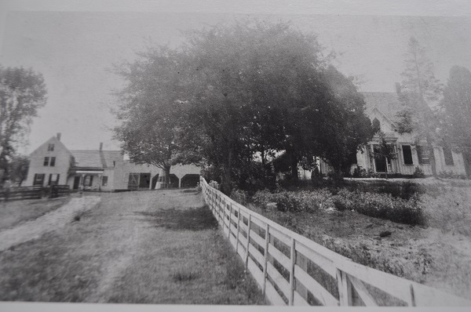
Question: What evidence is there here that the Waterman family seems to be prospering? How does this homestead compare to that of the Merrill Boodey family?
Source of all the above images: Robert P and Jeanette K Bishop- The 1858-1863 Letters of George Lawson Waterman, from School to War- Peninsula Historical Society, 1996

Waterman Family and Lieutenant George L. Waterman’s Gravestones and Inscriptions in Cedar Grove Cemetery, Peninsula
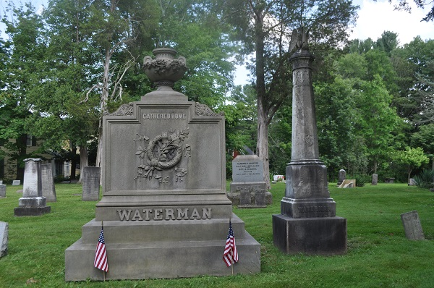
Close-ups of Lieutenant Waterman’s Gravestone and Memorial
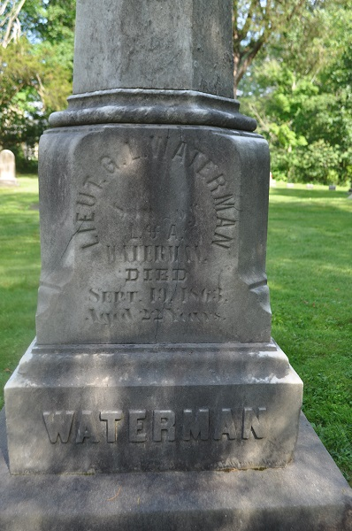
First Inscription- “He died that his country might live”
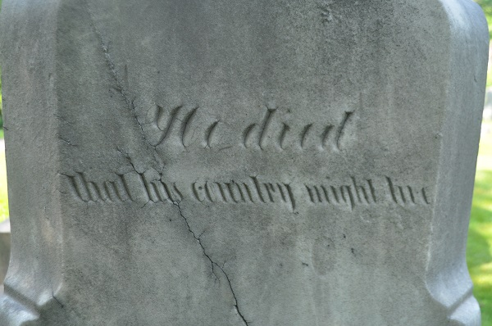
Second Inscription- “In memory of our Soldier son”.
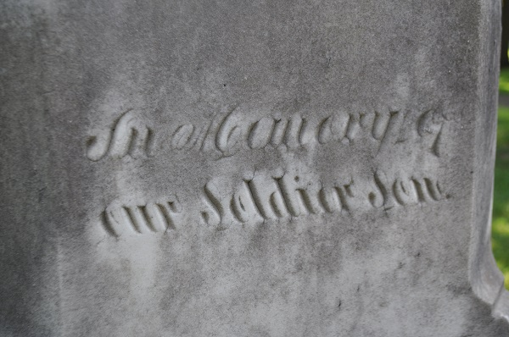
Source of Cemetery Images: Paul Frankmann
Questions: What does the Waterman family gravesite including Lieutenant Waterman’s own grave say about the role played by the Waterman family in Peninsula? How do the inscriptions and symbols on Lieutenant Waterman’s grave relate to what he wrote in his letters?

